CSC 455: Database Processing for Large-Scale Analytics

Assignment 1

Akhil Kumar, Ramasagaram (Student ID: 1488438)

Part 1
Create a set of relational schemas with underlined (primary) keys and arrows connecting foreign keys and primary keys for a database containing the following information. If you have any difficulty drawing arrows, you can write foreign key information in a sentence instead.
- Authors have Last Name, Firstname, ID, and Birthdate (identified by ID)
- Publishers have Name, ID, address (identified by ID)
- Books have ISBN, Title, Publisher (each book has a unique publisher and can be identified by ISBN).
- Authors Write Books; since many authors can co-author a book, we need to know the rank of an author contributing to a book, stored in this table (i.e. a number 1, 2, 3; for single author books, this number is 1).
Ans:
Authors
Author ID
Last Name
First Name
Birthdate

Publishers
Publisher ID
Name
Address

Books
ISBN
Title
Publisher ID
Write
Book ISBN
Author ID
Book Rank

We have created 4 tables named Authors, Publishers, Books and Write. The primary keys are Author ID, Publisher ID and ISBN for table Authors, Publishers and Books respectively. The Book ISBN in Write table is foreign key which is referred to the primary key of Books table called ISBN. The Author ID in Write table is foreign key which is referred to the primary key of Authors table called Author ID. The Publisher ID in Books is foreign key which is referred to the primary key of Publishers table called Publisher ID.

Part 2

- Using your logical schema from Part1, write the necessary SQL DDL script to create the tables. Be sure to specify every primary key and every foreign key. You can make reasonable assumptions regarding the attribute domains.

Ans:
CREATE TABLE Authors
(
AuthorID VARCHAR2(10),
Lastname VARCHAR2(30),
Firstname VARCHAR2(30),
Birthdate DATE,

CONSTRAINT Authour_PK
PRIMARY KEY(AuthorID)
);
CREATE TABLE Publishers
(
PublisherID VARCHAR2(10),
PublisherName VARCHAR2(30),
Address VARCHAR2(40),

CONSTRAINT Publisher_PK
PRIMARY KEY(PublisherID)
);
CREATE TABLE Books(
ISBN VARCHAR2(15),
Title VARCHAR2(30),
PublisherID VARCHAR2(10),

CONSTRAINT ISBN_PK
PRIMARY KEY(ISBN),

CONSTRAINT Pub_ID
FOREIGN KEY(PublisherID)
REFERENCES Publishers(PublisherID)
);
CREATE TABLE Writes
(
Book_ISBN VARCHAR2(15),
AuthorID VARCHAR2(10),
Book_Rank NUMBER(1),

CONSTRAINT Aut_FK
FOREIGN KEY(AuthorID)
REFERENCES Authors(AuthorID),
CONSTRAINT Book_FK
FOREIGN KEY(Book_ISBN)
REFERENCES Books (ISBN));

- Write SQL INSERT statements to populate your database with the following data (NOTE: remember that strings would need to use single quotes, e.g., 'Asimov')

  - (King, Stephen, 2, September 9 1947)
INSERT INTO Authors VALUES ('2','King', 'Stephen', '09-Sep-1947');
  - (Asimov, Isaac, 4, January 2 1920)
INSERT INTO Authors VALUES ('4', 'Asimov', 'Isaac', '02-Jan-1920');
  - (Verne, Jules, 7, February 8 1828)
INSERT INTO Authors VALUES ('7','Verne', 'Jules','08-Feb-1828');
  - (Rowling, Joanne, 37, July 31 1965)
INSERT INTO Authors VALUES ('37','Rowling', 'Joanne', '31-Jul-1965');

  - (Bloomsbury Publishing, 17, London Borough of Camden)
INSERT INTO Publishers VALUES ('17', 'Bloomsbury Publishing', 'London Borough of Camden');
  - (Arthur A. Levine Books, 18, New York City)
INSERT INTO Publishers VALUES ('18', 'Arthur A. Levine Books', 'London Borough of Camden');

  - (1111-111, Databases from outer space, 17)
INSERT INTO Books VALUES ('1111-111','Databases from outer space', '17');
  - (2222-222, Dark SQL, 17)
INSERT INTO Books VALUES ('2222-222','Dark SQL', '17');
  - (3333-333, The night of the living databases, 18)
INSERT INTO Books VALUES ('3333-333','The night of living databases', '18');

  - (2, 1111-111, 1)
INSERT INTO Writes VALUES ('1111-111','2','1');
  - (4, 1111-111, 2)
INSERT INTO Writes VALUES ('1111-111','4','2');
  - (4, 2222-222, 2)
INSERT INTO Writes VALUES ('2222-222','4','2');
  - (7, 2222-222, 1)
INSERT INTO Writes VALUES ('2222-222','7','1');
  - (37, 3333-333, 1)
INSERT INTO Writes VALUES ('3333-333','37','1');
  - (2, 3333-333, 2)
INSERT INTO Writes VALUES ('3333-333','2','2');

- Write a python function that is going to generate and return a SQL INSERT statement given a table name and value list as parameters. For example, generateInsert('Students', ['1', 'Jane', 'A-']) should return “INSERT INTO Students VALUES (1, Jane, A-);”. It would be even better, but not required if your function returned the more proper “INSERT INTO Students VALUES (1, 'Jane', 'A-');” (i.e., put quotes around strings, but not numbers).
Another example: generateInsert('Phones', ['42', '312-555-1212']) would produce “INSERT INTO Phones VALUES (42, 312-555-1212);” For simplicity, you can assume that every entry in the list of values is given as a string, even if it is a number.

Ans:
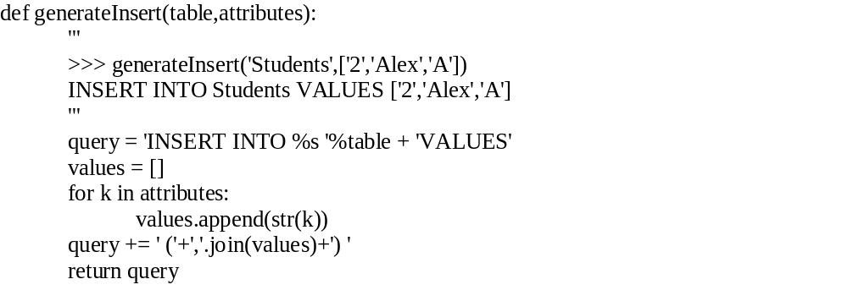

You should submit your SQL and python code for this part (you may copy everything into your Word document submission, or submit it as separate files).

Part 3

Consider a MEETING table that records information about meetings between clients and executives in the company. Each record contains the names of the client and the executive’s name as well as the office number, floor and the building. Finally, each record contains the city that the building is in and the date of the meeting. The table is in First Normal Form and the primary key is (Client, Office).
(Date, Client, Office, Floor, Building, City, Executive)

You are given the following functional dependencies:
Building → City
Office → Floor, Building, City
Client → Executive
Client, Office → Date

- Remove any existing partial dependencies and convert the logical schema to the Second Normal Form. Please remember that when performing schema decomposition you need to denote primary key for every new table as well as the foreign key that will allow us to reconstruct the original data.
Ans:

A Partial Dependency is a functional dependency where the determinant is a subset of primary key. Here the Partial dependency is Client → Executive. The 2NF is 1NF with every attribute in the table is determined by the entire primary key. So the Client → Executive FD is removed and transformed into Client, Office → Executive, Date.

Client
Office
Executive
Date

Office
Floor
Building

Building
City

- Remove any existing transitive dependencies to create a set of logical schemas in Third Normal Form. Again, remember to denote primary keys and foreign keys (including which primary key those foreign keys point to).

Ans: In the above example there exist a transitive dependency. Building → City & Office → Floor, Building, City. Due to this FD Redundancy is caused so the relation is decomposed into. Building → City & Office → Floor, Building. The 3NF states that every attribute in the table is determined by the primary key of the table.

Client
Office
Executive
Date

Office
Floor
Building

Building
City
Part 4

Consider a table that stores information about students, student name, GPA, honors list and the credits that the student had completed so far.

(First, Last, GPA, Honor, Credits)

You are given the following functional dependencies

First, Last → GPA, Honor, Credits
GPA → Honor

- Is this schema in Second Normal Form? If not, please state which FDs violate 2NF and decompose the schema accordingly.

Ans:

Yes, the above functional dependencies are in Second Normal Form, because according to 2nd normal forms. Every attribute in the table is determined by the entire primary key. But it also causes the Data Redundancy as the attribute Honor is repeated twice. So for that we need to decompose the schema into. Here the Primary key in first FD is First & Last and the GPA from the second FD is foreign key referencing to the GPA in second FD
- First, Last → GPA, Credits
- GPA → Honor

- Is this schema in Third Normal Form? If not, please state which FDs violate 3NF and decompose the schema accordingly.

Ans:

No, the above functional dependencies are not in Third normal form, because the 3rd normal form states that every attribute must be determined by the primary key of the table. So for that purpose we decompose the table into following. Here the Primary key in first FD is First & Last & the GPA in the 2nd FD is the primary key. The GPA in 1st FD acts s foreign key which references values from the 2nd FD.
- First, Last → GPA, Credits
- GPA → Honor

